|  |  |  |
| --- | --- | --- |
| Debabrata Pramanik  Dept. of Computer Science  Kent State University  Kent, Ohio-44240  dpramani@kent.edu | Saksham Yadav  Dept. of Computer Science  Kent State University  Kent, Ohio-44240  syadav1@kent.edu |  |
|  |  |  |

Smart Plant Watering System Using Internet of Things and Google Spreadsheet

*Abstract*— as future is moving towards the Internet of things with processes controlled by devices. The prediction is that number of IOT devices would be drastically increased by five times by the year 2020.The data collected by IOT [1][2] devices is very large. The interaction between the IOT devices is so large that we need to do some analysis and built customized application based on the results from data collection. So we thought of trying to integrate the capability of the Internet of things with data collection techniques and built an application that showed light on what is happening with IOT devices and how we can adopt to those situations. We will be studying how we can automate the systems and also provide a graphical user interface of real time automation. When tackling a real world problem, we should also integrate the data we collected and analyzed in some format which can be used to build a complete eco-system to get some fruitful outcome. We are trying to integrate all these process in our proposed system.

Keywords: IOT, Watering System

OUTLINE OF THE PAPER

In this paper we will be introducing a general idea of what Internet Of things is in section 1. Related Work in Section 2. We will talk about architecture used in our project in section 3. We will talk about hardware used in section 4. We will talk about the software used in section 5. This is followed by Rules formation and preprocessing we have done in section 6. Our Final application in section 7 followed by Future work and scope of our project in section 8.

1. INTRODUCTION

Internet of things refers to integration of hardware and software to control and solve day to day processes by using simple devices and trying to make them autonomous by using the data collected from the sensors. The application of Internet of things has its application ranging from the development of autonomous machines (M2M) learning to various use cases of our daily life. For example, the one parking prediction done by BMW, smart umbrella which informs the owner to carry along whenever there is prediction of the rain by checking with the local weather system. So incorporating intelligence of decision-making by using data mining techniques and helping the IOT devices, mainly automated sensors to carry out some useful purpose that can simplify the human daily routines and automate the system based on some simple integration of data collection techniques with the capabilities of Internet of things.

Our paper is focused on making smart watering system to the plants by studying the various characteristics of the surrounding environment by integrating data collection techniques and capabilities of IOT. When it comes to watering the plant in large scale greenhouse facilities or maintenance of large parks or where there is dense irrigation land we waste lot of human resources. There are situations where plants die due to scarcity of water served to them. Thus we are trying to automate the process and to make precise decision to make the system automated and independent of human supervision where the machine can understand when the plants need water and when the plants don’t need water. We also thought there will be regions which are not reachable by human beings, like terrain regions where watering to the irrigation land will be difficult as the person has to go and regularly check the condition of the plant in the region regularly is both time consuming and waste of human resource. So we are trying to propose a system which not only provides automatic sprinkling of water to the plants but also add intelligence to the system and make it more efficient.

Basically in nutshell our system aims to address the issues of the farmers, greenhouse maintenance and large parks which can implement our system according to their specific needs and our system can automatically serve the water according to the need of the soil. Consequently, saving the time and also contributing to the maintenance and the balance of the ecosystem by using simple capabilities of IOT and adding smart objects in making the whole process free from human interaction.

The problem of maintenance of plants not always concern big organization or eco reserves but also our daily lives at our home. We do face the challenge of watering our plants in our garden. Consider a scenario when we are moving out of our house for long duration. We have two option we can ask someone in the neighborhood or keep a help for that period which is difficult or we let the plants be neglected. So our proposed system will come into picture at even at household level. Our proposed system will address these issues where the individual just need to place our system at their garden and let our system do all the magic of maintaining of watering of plants and considering all the environmental factors before making the decision to water the plant and also what amount is sufficient for the maintain of plants.

Furthermore, incorporating data mining techniques on the data collected from sensors help us to determine the precise conditions when the system should start and stop. If our system is used by organization. We can customize our application so that the organization can also keep track of plants. In case some sensors or not working or there is some problem with the automated system.

1. RELATED WORK

The work regarding the smart watering system is done earlier as well. The papers [3][4][5] talks about architecture which involves the sensors placed statistically at places to measure the soil humidity and a motor controlling the electro valves which in turn controls the water flow to the plant. They had developed a Java application which stores when the plants have been watered in an SQL database. The research paper throws light on the implementation of the smart watering system using single attribute, which is the soil humidity of the pot. The humidity sensors collect the data from the soil and save it in MYSQL database. The paper considers only the humidity as the criteria to water the plants.

The paper also talks about the application talks about the analysis of their autonomous system and also it gives the comparison of their automated system with the traditional system where the water used to give to the plant in uncontrolled amount. With the traditional automated systems there were problems such overwatering of water to the plants due to surplus amount of water being poured which would cause the plants to decay and in some rare cases plants would dry out due to improper functioning of the automated system

However, with the extension of the above research our research paper incorporates other factors along with the humidity of the soil to further enhance the system and make it more precise. Along with the data collection this research paper also refers to the implementation of the data mining techniques used to classify the instances into YES or NO whether to water or not just by single factor. We are considering many factors such as whether it is day or light, temperature, humidity and also whether it is raining or not and make the system intelligent not just automated like many other options that are available in the market.

Our research paper considers attribute which are responsible for the efficient running of the system. The attributes referred in our paper includes temperature, light, moisture, humidity.

The final output of our project is an application that shows the area where the plants need to the watered. If implanted in stand-alone architecture, we have included an option to send the text messages to the potential customer.

1. ARCHITECTURE DESIGN

The system architecture includes the sensors, microprocessor as raspberry pi, an ADC (Analog to digital Converter) MPC 3008, breadboard, jumper wires, temperature sensor, soil moisture sensor, humidity sensor, light sensor, camera. The different sensors collects the data from the soil and environment in which the plant is placed. The sensors are controlled using a microprocessor as raspberry pi with a Arduino connection to it for soil moisture sensing. Raspberry pi runs the python scripts to collects the data from the sensors and pushes this data to a google spreadsheet using a google application programming interface.

The correctly classified data gives the decision tree which is used to decide when the system should be active and when it should be deactivate according to the conditions of the environment observed from the sensors.

1. HARDWARE USED

The sensors used in our system include the photodiodes. The role of the photodiode is to collect the analog data about the light sensitivity. Photodiodes are sensors that allow you to detect light. They are small, inexpensive, low-power, easy to use and don't wear out. For that reason, they often appear in toys, gadgets and appliances [6]. The light sensitivity is used to collect the information whether the time is day or night. The plants are not served with the water at night time. Thus, the system deactivates if the light sensitivity is low. Along with photodiode, a temperature and humidity sensor is used to determine the temperature of the environment and humidity of the air. The pre-wired and waterproofed version of the DTH22 sensor. Handy for when you need to measure something far away, or in wet conditions. The system will be activated and deactivated according to the preset preferences. The optimum temperature is sensed using the temperature sensor to activate the system. The DHT22 is a basic, low-cost digital temperature and humidity sensor. It uses a capacitive humidity sensor and a thermistor to measure the surrounding air, and spits out a digital signal on the data pin of the Raspberry Pi (no analog input pins needed) [8].

The humidity sensor determines the humidity of the soil. The humidity sensor checks for the level of humidity at specific time interval to decide whether the humidity of the soil is low of high or medium. The chip MPC 3008 is used to convert the analog readings captured by moisture sensor and photodiode.

The soil moisture sensor is added to the system with the help of an Arduino board. Soil moisture sensor checks the soil moisture of the soil.

We have used Raspberry pi in order to integrate the sensors and the sensors we will be using in our project. The role of raspberry pi is to run the python scripts and push the data into google spreadsheet. First The Raspberry pi reads the digital data. So we have used Analog to Digital Convertor in order to convert the value we have got from Sensors. Along with handling data Raspberry pi also acts like a back end of our application to push the data into our server for the proposed application. This is used to show the area where plants need water and along with the option in the application that sends the email to the potential customer. We have also used jumper wires and breadboard is used to connect raspberry pi with the sensors. An overview of our hardware given through the following images:

DHT22 (Humidity Temperature Sensor)

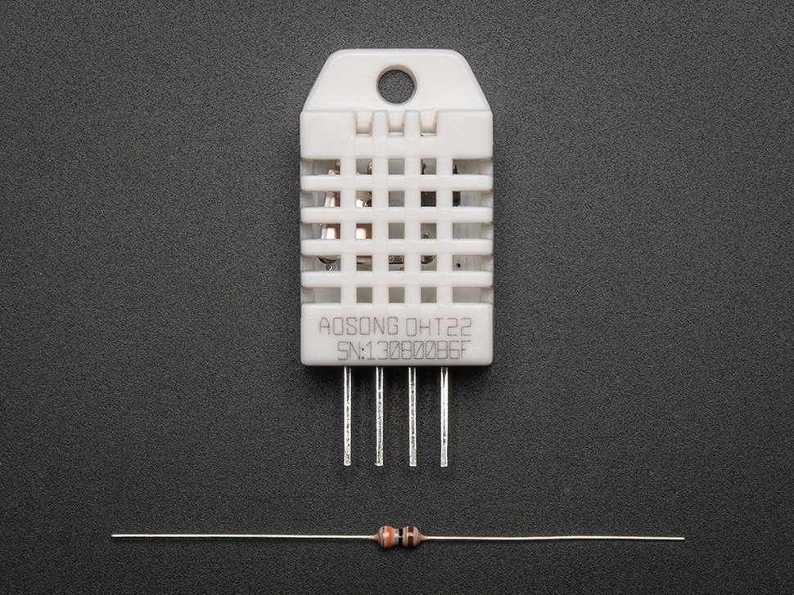

Photo Cell (Light Sensor)

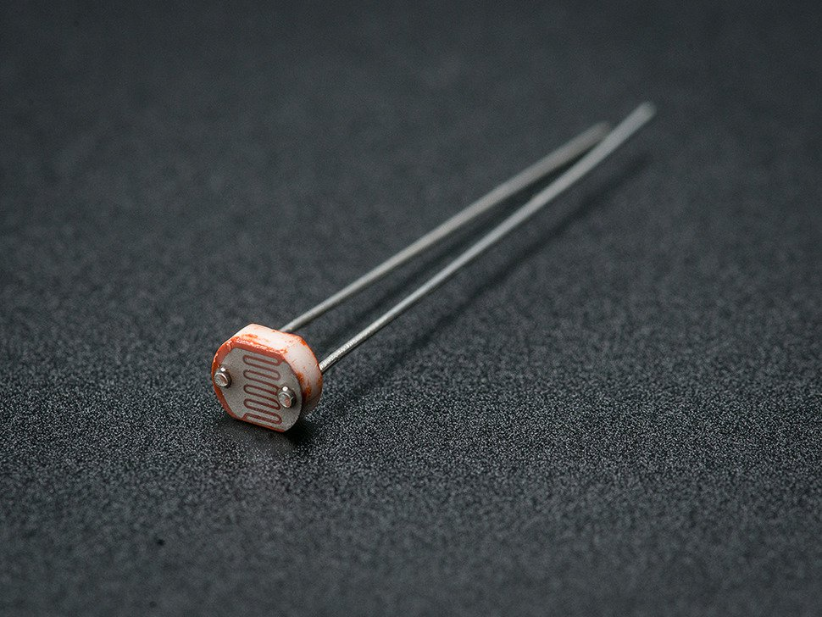

Arduino Uno 3

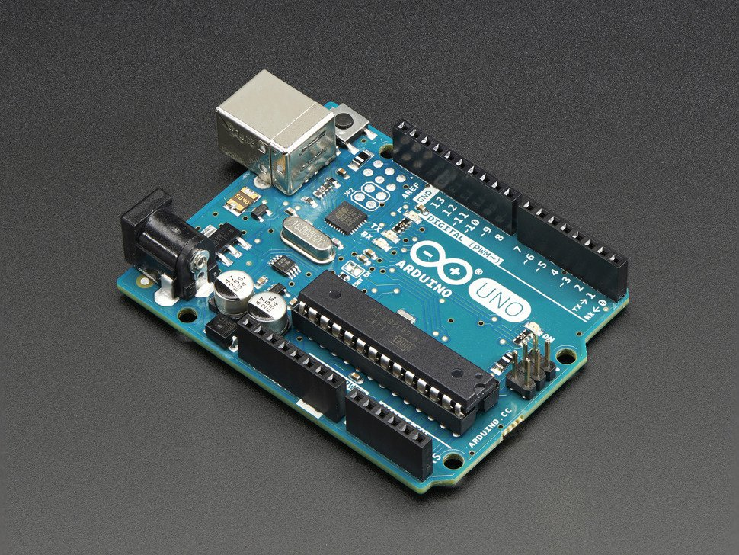

FC 28D ( Soil Moisture Sensor)

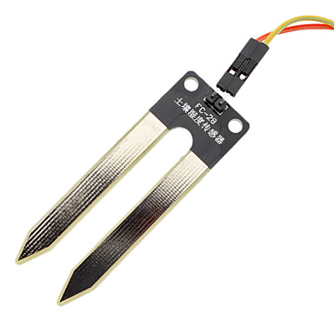

Raspberry Pi

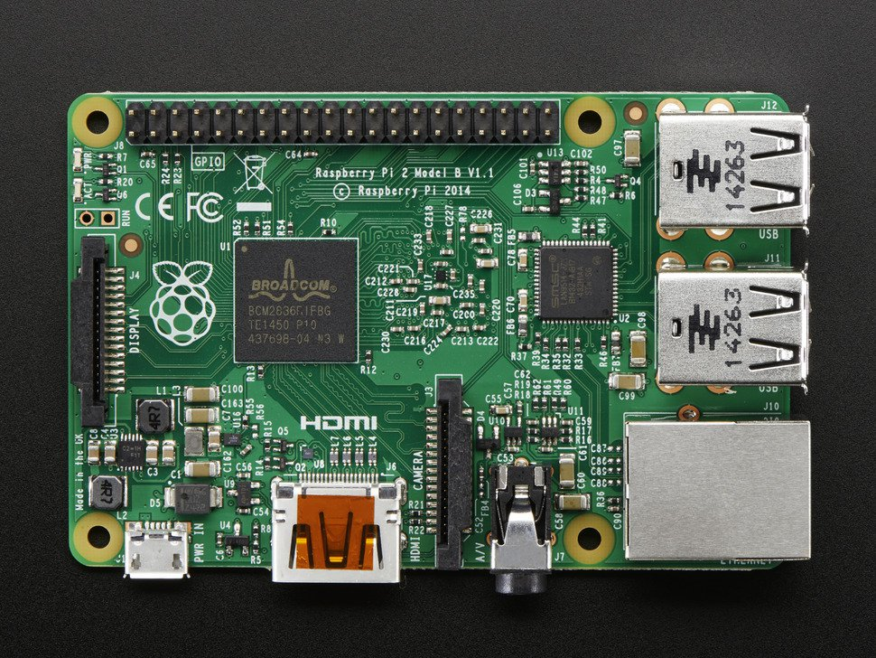

# SOFTWARE USED

The data is collected by the sensors for experimenting purpose by using hardware components and is then pushed into the google spread sheet. For using this, a google API is downloaded which keeps a track of the registered email address to which the collected data is to be sent. The data is pushed into the storage using python scripts and google doc API. Google APIs are a set of application programming interfaces that allows communication with various google applications, here it allows us to communicate with Gmail.

Finally, with the use of a decision tree, an application is developed using Java to load the data into the system and classifies the data into the “YES” or “NO” to automate the process. The application also sends email to the user when the system is active and inactive according to the current situation of the system.

1. PRE PROCESSING OF DATA

The data we had got from the google spreadsheet is read directly. We have a bunch of attributes and their values. We had some difficulty in pre-processing such huge data we had and we didn’t have any classification criteria to classify these attributes. So we had to classify the values and label the attributes according to the range of values that had been collected by us. So we came up with bunch of labels which was useful in deriving the result.

We had basically, attributes of light, humidity, temperature, moisture. We needed these values somewhat classified based on some criteria. So we came up with bunch of labels to classify the data.

TABLE 1

Pre Processing of light values.

|  |  |
| --- | --- |
| **Light** | **Values** |
| Day | <20 |
| Night | >20 |

Pre-processing of light attributes the light values that we selected were according to data we collected. We collected the data, and after careful observation and analysis we came into conclusion that these light values during the night came out to be less than 20 value. Going by the condition we deduced, whenever we recorded light values to be less than 20 we marked it as day. However, when we get light values above 20 we marked it as day as shown in Table 1

TABLE II

Pre Processing of temperature values.

|  |  |
| --- | --- |
| **Temperature** | **Values** |
| Low | <50 |
| Medium | 50-80 |
| High | >80 |

After careful analysis of the cases we observed that the whenever the temperature is low, the evaporation of water is less. And when the temperature is medium the evaporation depends on the light conditions and when the temperature is high the evaporation is also more. So we categorized out r = temperature into 3 categories. Whenever the temperature is recorded below 50 degrees we marked it as LOW, when the temperature is recorded in between 50 to 80 degrees we marked it as MEDIUM and the last one is when the temperature is above 80 degrees we marked it as HIGH as shown in Table 2

TABLE III

Pre Processing of humidity values

|  |  |
| --- | --- |
| **Humidity** | **Values** |
| Low | <25 |
| Medium | 25-60 |
| High | >60 |

As of humidity we collected some data and we saw that the content of water was very less in the soil when the humidity came out to be less than 25%. And when the humidity recording gave us the reading of humidity between 25% and 60% we observed that the water content in the soil was in moderate amount that can be used by the plants for some time. And when the reading was more than 60% we saw that the amount of water content was in sufficient amount in the soil and that can be used by the plant for a long period of time.

So observing the values of moisture in the soil we categorized the values of soil moisture in 3 categories. Whenever the moisture in the soil is recorded less than 25% we categorize it under LOW category. When the soil moisture is recorded somewhere in between 25% to 60% we categorized it into the second category that is the moderate amount of water content into the soil and we named it as MEDIUM category. Then for the third category whenever the recording was above 60% of moisture in the soil. This means that there is sufficient amount of water content in the soil and that can be used by the plant for a long period of time so we categorized that into HIGH category. This is shown in Table 3

1. DEFINING OF RULES

TABLE IV.

Rules Defined for Watering System

|  |  |  |  |  |
| --- | --- | --- | --- | --- |
|  | **Humidity** | | | |
| **Temperature** |  | *Low* | *Medium* | *High* |
| *Low* | NO | NO | NO |
| *Medium* | YES | NO | NO |
| *High* | YES | YES | NO |

After the preprocessing we set few rules for the working condition of our system. It will go to check for the light condition if the light says that it is night time i.e. the light value recorded was below 20, so we know that plants don’t need water at night time so our system will go to the no condition where our system don’t work. But if it is day time i.e. if the recorded value of light is more than 20 the plants can require water so it will check for the next condition i.e. the temperature condition and it check for category of temperature. If the temperature is low, we say that the evaporation of water will be less and the plants will need very less water so our system goes to no without checking for the humidity condition. But if the temperature is from the medium category i.e. between 30 degrees to 40 degrees, then the humidity category will be checked. If the humidity is low i.e. less than 30% this means that water content in the soil is low and plant will be out of water any time soon soil can require water anytime so our system will go to yes condition and will start working. However, if the humidity condition is medium i.e. between 30% to 60% this means the plant has enough water for the plant process and as the evaporation will also not be much in medium temperature so the water won’t be required so our system goes to no condition and won’t work. Similarly, if the humidity condition is high i.e. above 60% with medium temperature the plants won’t be requiring a lot of water so the system goes to no and the watering system won’t work. For the third category of temperature i.e. when the temperature is recorded as high i.e. above 40 degrees, again the system will check for the humidity condition in the soil. if the humidity is low i.e. less than 30% content is there in water this tells that the evaporation of water will be more and plants will require water soon. So our system will go to yes condition and will start watering the plants. Similarly, if the humidity condition is medium i.e. between 30% to 60% the plants will require water soon as the high temperature will evaporate water more and decrease the water content in the soil so our system will go to the yes condition and will start watering the plants. But for high temperatures if the humidity is from the high category i.e. the soil is having more than 60% water content, this says that there is enough water content in the soil to be used by the plant to for its process so our watering system will go to the no condition and our system won’t water the plants. So these are all the conditions that are defined by us for working or not working of the watering system. Table 4 shows the rule that we had considered between temperature and humidity. Fig 1 shows the pictorial representation of the decision process we had come up with.

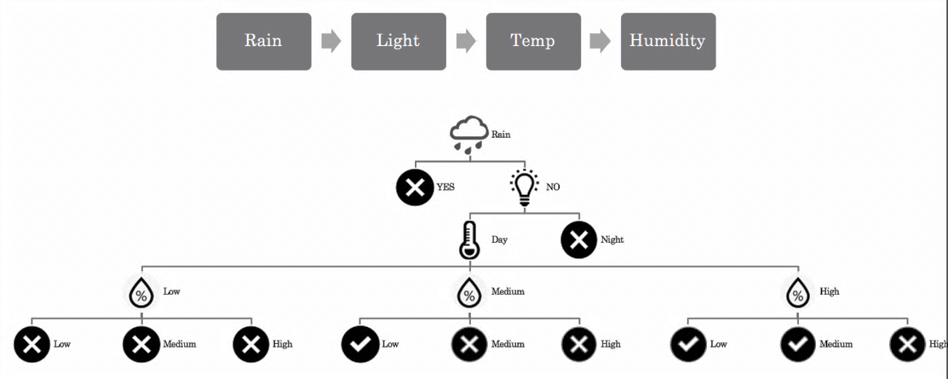

1. Pictorial Representation of the Rules we had come up with. The X symbol represents Water need be done and Right symbol represents that plants need to be watered.
2. FUTURE WORK AND SCOPE

We are thinking of considering more factors such as PH value and also plants specific criteria such as potassium level, chlorine value. Also we need to consider about the time interval between sprinkling also. Just watering based on the values would be ideal case. Also we can create a mobile application and online website where people can buy and register our products for their home usage. We are also thinking of approaching Greenhouse, local parks and propose our idea and our product.

Approaching the university to try out system and avoid cost cutting in the maintenance of grass and plants in the university is also in our minds.

We are also thinking of giving it remote access through mobile and make a system of ten raspberry pi’s for a combined data collection.

# References

[1] Y. Li, M. Hou, H. Liu and Y. Liu*. ” Towards a theoretical framework of strategic decision, supporting capability and information sharing under the context of Internet of Things”*, Inf. Technol. Manage., vol. 13, no. 4, pp.205 -216 2012

[2]Jayavardhana Gubbi, Rajkumar Buyya Slaven Marusic and Marimuthi Paliswamia. *Internet of Things (IoT)*, *a vision, architectural elements, and future directions*. SciencDirect. Volume 29 Issue 7, September 2013, pp 1645-1660

[3] C. M. Angelopoulos, S. Nikoletseas and G Constantinos. *A Smart System for Garden Watering using Wireless Sensor Networks* MobiWac’11, October 31–November 4, 2011, Miami, Florida, USA.

[4] M. Dursun and S. Ozden. *A wireless application of drip irrigation automation supported by soil moisture sensors.* Scientific Research and Essays, Vol. 6(7), pp1573– 1582, 2011.

[5] Balendonck and al. Sensors and Wireless Sensor networks for irrigation management under deficit conditions (flow-aid). In International Conference on Agricultural Engineering (AgEng2008), 2008.

[6] Adafruit (July, 2012) *Usage of Photodiode and the circuit connection to Raspberry pi* [Online]. Available: <https://learn.adafruit.com/photocells/>

[7] Adafruit. *Usage of Temperature sensor and the circuit* [Online] Available: <https://www.adafruit.com/products/381>

[8] Adafruit: *Usage of the sensor and connection to the Raspberry Pi and the circuit* [Online]. Available: <http://www.adafruit.com/products/385>